**Clojure Problem Set Outputs**

Question 4:

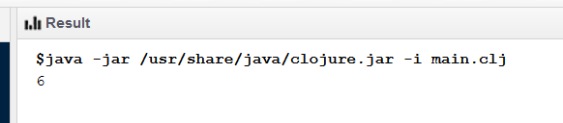

Question 5a:

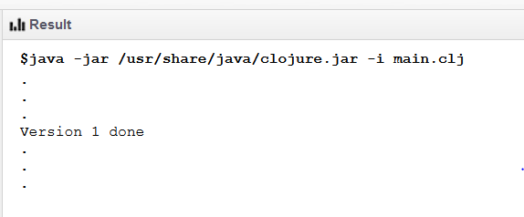

Question 5b:

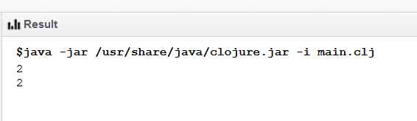

Question 6:

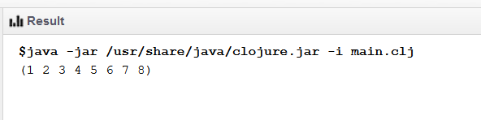

Question 7:

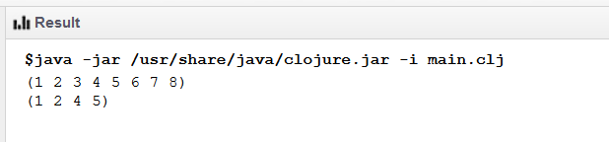

Question 8:

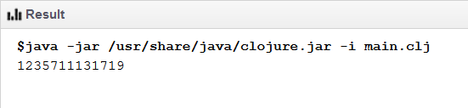

Question 9:

